# Food Quality Of Cafeteria in IBA Sukkur

Supervised by: Dr Sher Muhammad Daudpota

Name : Sareeka

**Introduction**

The dinning experience in our University Cafeteria is fundamental to customer satisfaction, which is depend on affordability, quantity and most important the consistency and quality of the food they served to their Customer. This Project is aimed to address the existing concerns like food quality according to different people who came from different areas how they like the food, quantity and consistency of food items which they offered in our Cafeteria.

The main objective of this Project is to Know how Student of Sukkur IBA feel about the food Quality in our Cafeteria and identify the causes of inconsistency of food experience. To do, this we are going to ask students for their feedback by using Survey and we analyze and observe how individuals who came from different regions have opinion about food Quality of cafeteria. Main Objective of this Project is find or understand the challenges associated with food quality.

**Problem Statement**

Recently, our Cafeteria has faced consistent concerns regarding fluctuation in price, and variability in the quality of food items they served, we see this perception of every individuals according to geographically. These issues prices and inconsistencies are affect on customer satisfaction and they take dinning decisions based on reviews and feedback from others. Moreover, these concerns have resulted in facing avoidance for weeks in particular food items. So, because of monopoly they are charging high prices, because students have no alternative.

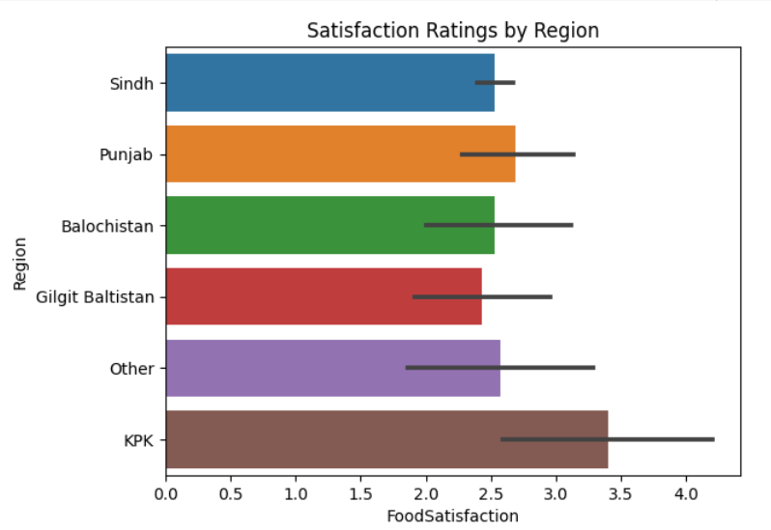

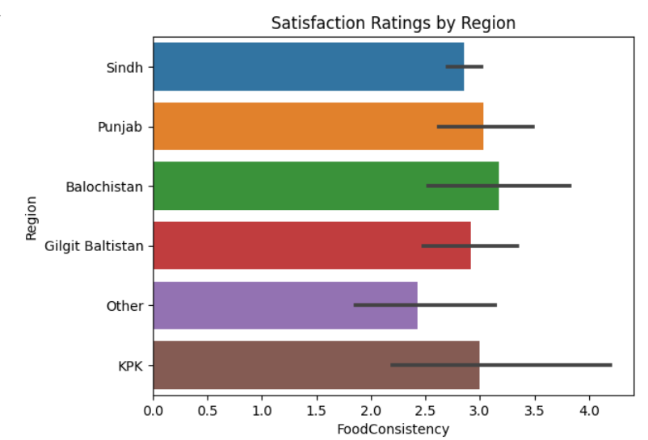

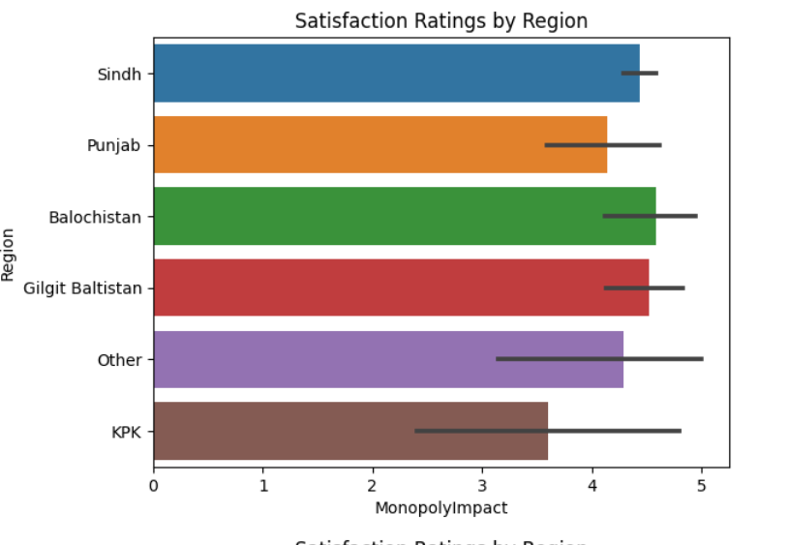

**Proposed Methodology**

1. **Data Collection :**

* In **IBA SUKKUR** there are students who came from different Areas and our main idea to collect data from those student so that we know there idea about quality of food of our Cafeteria. Simply, We are collecting data through **SURVEY FORM.**In which we collect data approximately 300 hundred from students of IBA Sukkur.

1. **Data Exploration**

* We are using EDA(exploratory data Analysis ) approach to understand the data distribution and visualization techniques to gain insights into the data.
* In which we use some of python libraries to visualize the data….

seaborn and matplotlib.pyplot

* Analyse Responses whether they are positive and negative

1. **Testing procedures**

* According to categorical and continuous data and having more than two categorical columns we decide to apply **ANNOVA TEST** to check our claim according to different region wise quality of food in our Cafeteria is rejected or accepted.
  + Library that we use is

import scipy.stats

* We extract two main columns from whole data which are “Region” and “FoodSatisfaction” to apply test to conclude the Hypothesis. And also see the difference of ratings through find mean of region wise ratings.

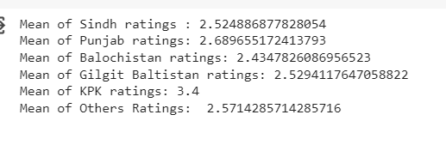

* We use these Formulas for F-Statistics

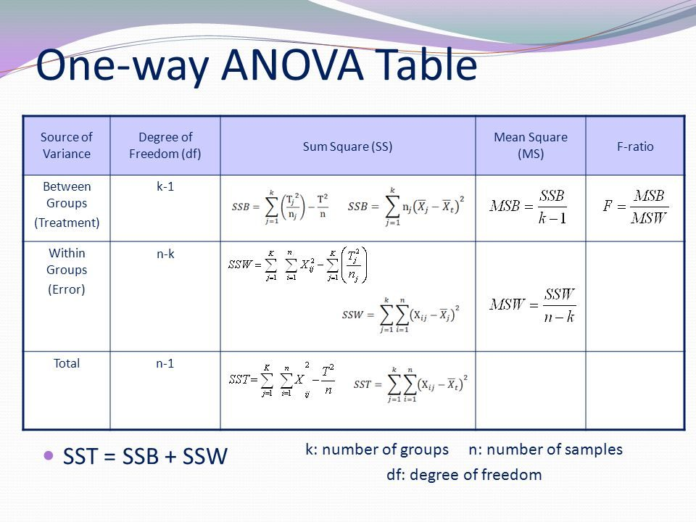

For F-Critical value we find through Python by writing this lines of code.

df_between = k-1

df_within = n-k

Alpha=0.05

critical_f_value = stats.f.ppf(1 - alpha, df_between, df_within)

Null Hypothesis => H0 **:**  There is no significant Difference in satisfaction ratings among individuals from different geographical regions.

Alternate Hypothesis => Ha **:** There is Significant Difference in satisfaction ratings among individuals from different geographical regions.

**Dataset Discussion**

In Dataset there are 10 columns , 303 Rows and the data we collect is Quantitative and Qualitative. The data we collect is on.

1. **Food satisfaction** according to different geographical R**egions**
2. **Food variety** where we observe that people are satisfied with the variety of food
3. **Cleanliness** here we see how they maintain the cleanliness of cafeteria
4. **Food Consistency**  sometime changes in test is not a big issue but frequently changes can keep customer away from that item so, in this we see the ratings according to Consistency
5. **Food Options**  here the main idea is to see are how people agree that food items change periodically.
6. **Monopoly Impact** here we see the ratings upon students have no any alternate to buy from this Cafeteria and charges are also high.
7. **Price satisfaction** see the students opinion regarding prices.
8. **Improvement Opinion** now here we want to get ratings due quality of food and are prices are according to quality.
9. **Preference Factor** most important thing when we chose food in cafeteria can be price, quality,fast service, variety and all of above these things we highlighted in our question.

**Major Outcomes**

1. The major outcomes of the study indicate that there is no statistically significant difference in satisfaction ratings among individuals from different geographical regions, confirming the acceptance of the null hypothesis

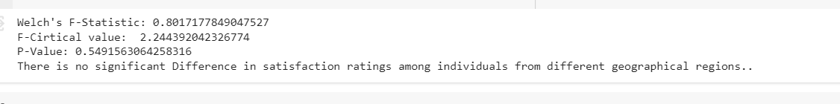

1. Reveal of inconsistency in satisfaction levels over time is not in so low



1. improvement in food quality and price are not according to quality this area need to be improve as per analysis. 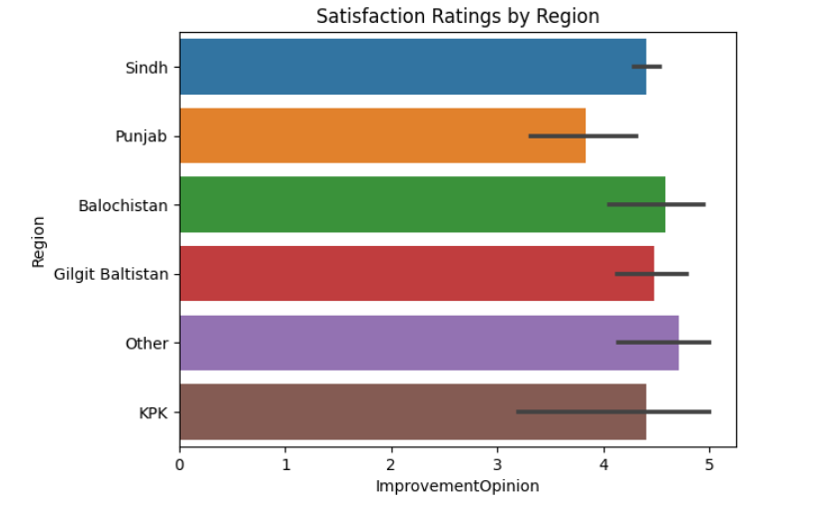

**Project Timeline**

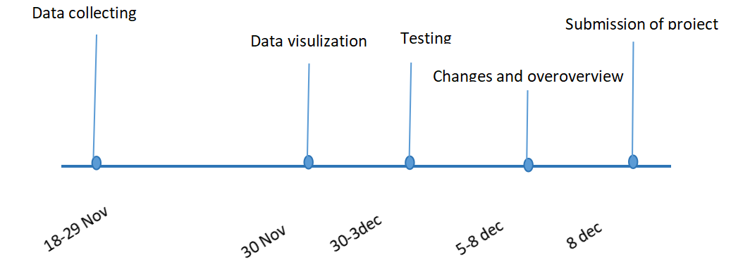

**Conclusion**

In conclusion , the study set out to investigate the satisfaction ratings among individual from diverse geographical regions regarding the food quality in our University cafeteria. The application of the ANOVA test has led to the acceptance of the null hypothesis, indicating that there is no statistically significant difference in satisfaction ratings across these regions.

**Reference**

<https://chat.openai.com/auth/login>

**Project implentation link:**

<https://drive.google.com/file/d/11UfN_yEz-dZ9-SCJnryj_e5dtXYfOZDX/view?usp=sharing>

**Dataset link**

<https://docs.google.com/spreadsheets/d/10D2s2wR8-pHt06Sbn0QjfO1UMOfLTElf1lrZ5Wx1mxU/edit?usp=sharing>